|  |  |  |  |  |  |  |  |  |
| --- | --- | --- | --- | --- | --- | --- | --- | --- |
| |  | | --- | | Caplock Mantispod Z tripod | | Product image thumb |  |  |  |  |  | | --- | --- | --- | --- | | Product image thumb | Product image thumb | Product image thumb |  | |  | **Specifications:**  **No:** P-GM-158.  **Materials:** Nylon + fiberglass, aluminum alloy.  **Net weight:** 250g.  **Size:** Package size90mm*265mm*67.5mm.  **Price: 50$** |

**Overview:**

**Caplock Mantispod Z tripod**

The Caplock Mantispod Z tripod is designed to be sturdy, durable, can withstand loads up to 1 kg and in extension mode is 1/2kg. The device is compatible with many types of action cameras as well as cameras smaller than about 1kg, smartphones. In particular, Caplock Mantispod Z has up to 5 shooting modes including: Mantis mode, handheld mode, extension mode, tripod mode and briefcase mode.

**Outstanding features of Caplock Mantispod Z**

Caplock Mantispod Z is a new tripod, with many improvements from the PGYTECH brand. This product has outstanding features such as:

There are 5 shooting modes: Mantis mode, handheld mode, extended mode, tripod mode and briefcase mode.

Mantis mode has been upgraded, allowing photos to be taken with many unique angles, opening up unexpected creative opportunities.

The minimalist, flexible design makes it easy to switch between tripod and handheld modes, selfie modes, and angle adjustments.

The ball-head gimbal allows for 360° rotation and seamless switching between landscape and portrait modes.

The CapLock system allows for one-step installation and the dual-lock design provides greater security.

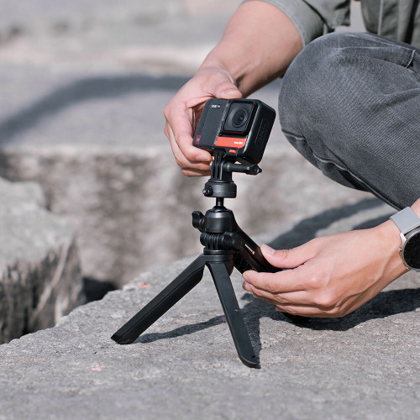

Note: Mantis mode is only applicable when the hanging surface is no more than 90mm thick and is supported from 2 other legs. Avoid hanging the device on vehicles, yachts, etc.